**YHCR – Then and Now**

Original scope was five WAVE 1 organisations who would be connected to YHCR via the physical Rotherham Infrastructure.

•       YAS (signed IG)

•       Doncaster

•       Rotherham (signed IG)

•       Humber (signed IG)

•       Leeds (signed IG)

Followed by a further six WAVE 2 organisations would connect to YHCR via the Google Cloud Platform (GCP)

•       York (signed IG)

•       NYCC (signed IG)

•       HUTH (signed IG)

•       NLAG

•       Bradford

•       Harrogate

There were also 9 Use Cases in the original scope, but a pragmatic decision was taken to prioritise the 11 organisations providing data into YHCR, before any specific use cases were addressed.

The original scope showed the 11 organisations providing data to YHCR by November 2019. That scope has now shifted to September 2020. Also YHCR is now funded by the three ICSs, and no longer by NHS England.

Currently the only YHCR elements of connectivity to the physical Rotherham Infrastructure are;

•       YAS provide Transfer of Care (ToC) messages which flow through YHCR to Leeds

•       Rotherham are gearing up to also receive these YAS ToC messages

•       Rotherham was connected to YHCR in a pilot mode, to provide four data items for 8 patients – the consumer for these patients (Leeds) is no longer capable of calling this data.

•       Some anonymised data flows from Rotherham FT to YHCR PHM

We are actively working to move the above elements from Rotherham Infrastructure to GCP and envisage this will be done by end August latest.

The latest progress of all 11 organisations is shown in the image below. NB. This diagram changes daily so be aware this is only a snapshot.

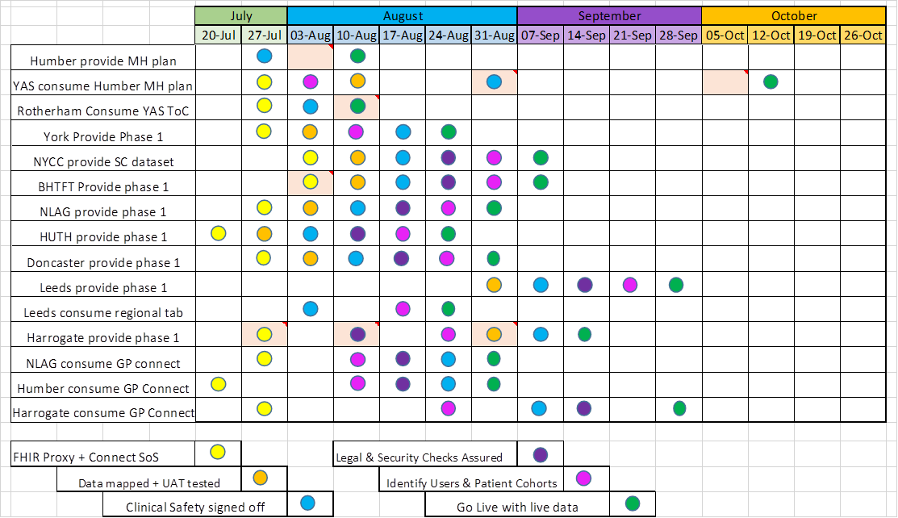

Currently the following Wave 1 or 2 organisations are connected to the GCP sandpit test environment;

•       HUTH

•       YORK

•       Bradford

•       NLAG

•       Humber

•       Leeds (consume)

•       YAS

In the very near future we expect Rotherham, NYCC and Doncaster to join them, leaving Harrogate as the last one (due to difficult system landscape). However even Harrogate should be connected to test during August and all 11 organisations are expected to be live providing data by end September.

The current YHCR team is not a long term consideration. Permanent roles are being advertised to take up post during September and provider a slimmed down YHCR presence post September.

This graphic shows the datasets proposed by the various organisations at  present.

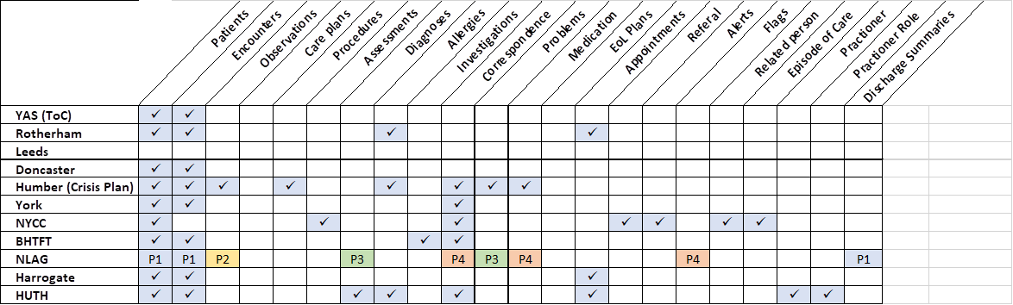

Besides the Wave 1 and 2 organisations, progress is being made with various other organisations/initiatives

•       HELM person held record

•       Sheffield Teaching

•       Sheffield Children’s

•       Barnsley hospital

•       Calderdale trust

•       Blackpear EoL initiative

•       WY & Harrogate maternity initiative

•       TPP Community data

Nigel Hodgson

Implementation Lead

Yorkshire & Humber Care Record